Reminders: Disconnect 9V battery when not in use. The battery drains quickly, and the more it drains, the slower your rover
UCI Life  Day 1 | Software  Day 2 | Hardware  Day 3 | Wiring & Testing  Day 4 | Skills Challenge  Day 5
 | Pi Introduction | Learn about computer vision code | Complete Wiring (See Diagram) | Learn about optimization parameters
 | Test Motors with 9V | HSV Values (Learn how to click the colors) | Test Wiring | Run Tournament
 | Test Cameras |  | Ensure Motors Have Proper Directionality
 | Learn about SSH/VNC | Fabricate the Hardware
By: AJ Calinisan acalinis@uci.edu
- Software
  - Pi introduction (Ernest’s slides)
    - Give out SD Cards with OS
    - Connect the Rpi to monitor
    - Connect Mouse and Keyboard
    - Rpi Setup
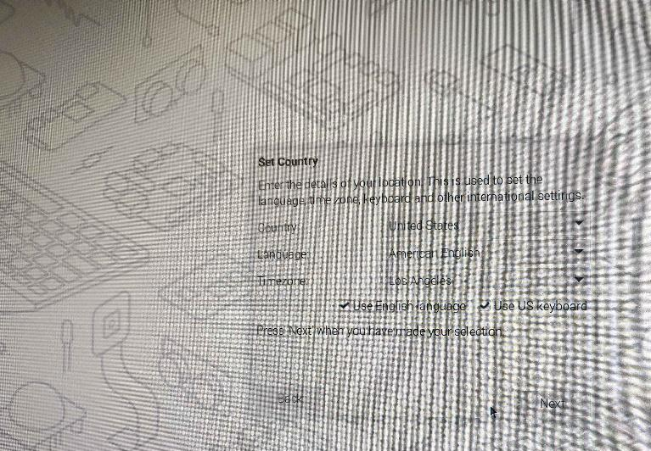
      - Setup user and pass
      - Connect to wifi
    - Frontload some terminal information
      - Explain how to use terminal (shortcuts?)
      - `sudo apt update -y`
  - Think about how the Robots will function. Two components:
    - Motors
    - Cameras
    - How do these work together to play soccer?
  - Test Motors
    - Use direct connection to 9V Battery
    - Ensure motors go backwards and forwards
  - ` sudo apt install python3-opencv python3-gpiozero python3-picamera2 -y`
  - Frontload information about how and why to use SSH/VNC
  - Test Camera
    - Connect the Camera (be careful)
    - Test with `rpicam-hello`
- Computer Vision, HSV, and Hardware
  - Test the Code
    - `sudo git clone https://rasp@github.com/ajcalinisan/aisoccerbot`
    - `cd aisoccerbot`
    - `python green_ball_tracker.py` (Requires Step I.d to be complete)
    - See if it can track a pickleball
  - Learn about HSV values and how opencv tracks colors
    - HSV color picker
    - Click the window in green_ball_tracker.py to see real-life values
  - Fabricate the base (See separate “SoccerBot Assembly” document)
- Wiring and Testing
  - Complete Wiring (See Wiring Diagram)
  - Test
    - Ensure motor_test.py has correct GPIO pins defined (by diagram:
      - right_motor = Motor(forward=17, backward=18)
      - left_motor = Motor(forward=22, backward=23)
    - Use motor_test.py to confirm forward, back, left, and right movements
    - Check to make sure camera still works
  - Run soccer_bots_no_preview.py on startup. Go to crontab section in README.md
  - Test Outside
    - Ensure that soccerbot works
    - Ensure soccerbot travels straight after it centers the ball in its camera
    - Modify soccer_bot.py
      - `sudo nano soccer_bot.py`
      - `sudo thonny soccer_bot.py`
      - Change these values especially RIGHT_SPEED and LEFT_SPEED (these speed values will likely both have to be 1.0 and 1.0 (not 1.0 and 0.7)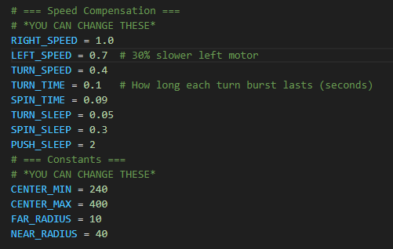
- Tournament Day
  - Further optimizations may be done by tweaking the SPEED, TIME, SLEEP, CENTER, and RADIUS parameters.
  - Run a bracket by timing each robot to see how long it takes them to push a ball out of a designated zone.

